Enter to Learn!
NEWSLETTER
Vol. 4 / Issue 33
May 14 ,2021
Leave to Lead!

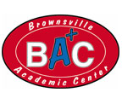

Principal’s Message
Folks, there’s 18 class days to go with the students. Let’s do our best to continue meaningful instruction throughout these last few weeks. Time will fly by real fast.
I want to congratulate the high school teachers. The two students that took the EOC exams have both passed. We received the good news yesterday. Special thanks to Ms. Morrison and Mr. Zamora. Both students took Biology and Algebra with these teachers and passed their EOC exams.
Round 2 of the Chapter Book Study started this morning. It seems like each chapter keeps getting better. I thank everyone for being positive with the presentations. A lot of preparation has been displayed. Keep doing a great job.
I’ve tentatively scheduled a faculty meeting for Tuesday. Hopefully there’s enough on the agenda to warrant holding a meeting. I will keep everyone posted. Have a great weekend!

Have a great weekend!

dHH

3
DOMAIN 1: STRONG LEADERSHIP AND PLANNING
BAC Ad Hoc committee has been working on a new improved discipline plan addressing the “Progressive Accumulation of Loss of Points” by students. A more comprehensive plan is being developed that now addresses loss of points on a daily/weekly basis both vertically and horizontally. Below is one of the plans presented by committee members.
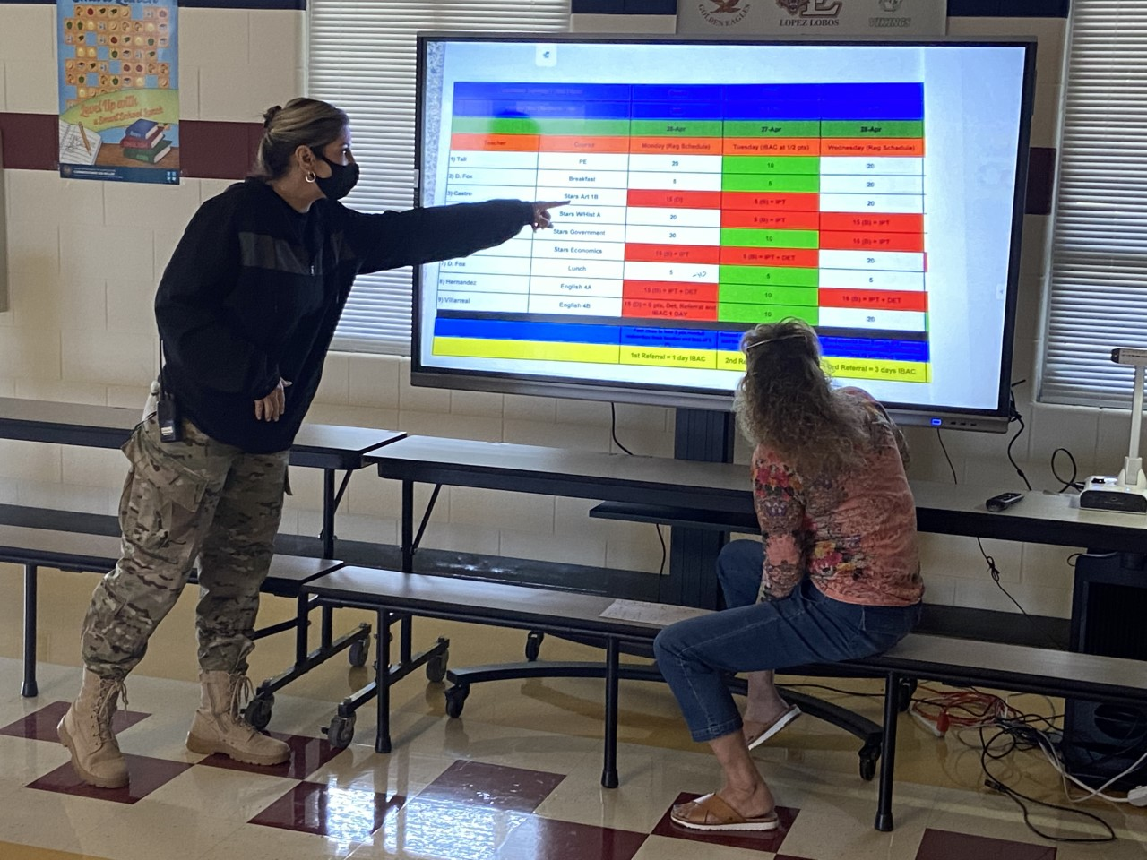
DOMAIN 3: POSITIVE SCHOOL CULTURE

Happy Nurse’s Day gift to Zac from the
Climate Committee
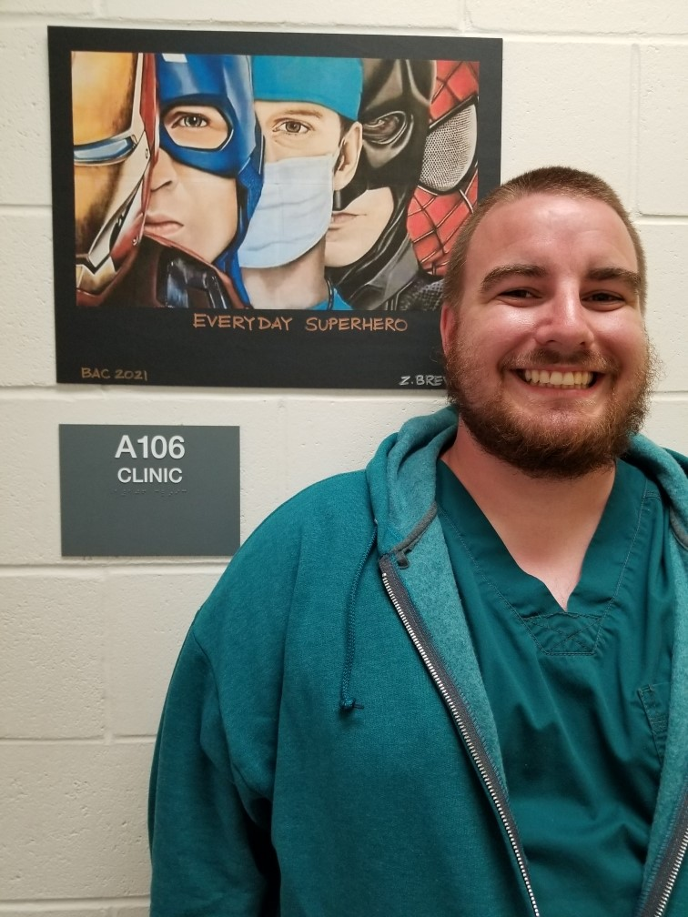

DOMAIN 2: EFFECTIVE, WELL SUPPORTED TEACHERS
DREAMS AND GOALS SHOW UP IN CONVERSATION …
EXPECTATIONS SHOW UP IN BEHAVIOR!

State assessments continue!
5/17/21 – DEIC meeting
18 class days left?
5/18/21 – Faculty meeting @8:00 am (tentative)
5/19/21 – Hump Day
5/20/21 – no news
5/21/21 – Chapter 7 Book Study Presentation

NEXT WEEK’S ACTIVITIES/EVENTS
DOMAIN 4: HIGH QUALITY CURRICULUM
- Teachers turn in commitment and stretch goals on all incoming students.
- Teachers incorporate a variety of supplementary materials and resources in their instruction. Some of these are:
Explore Learning Gizmos, BrainPop, Kahoot, Biology Junction, Interactive Animations, Kahn Academy, Discovery, National Geographic, Edusmart, Pearson Workbook, API Health and Wellness Modules, Teen Health and Nutrition Curriculum, Center for Disease Control and Prevention for the latest Covid-19 information, Read Works, SIP material and strategies, Flipgrid, Gretchen Barnebe Strategies, Commonlit,org
- Administration continues to reinforce and remind all teachers to follow the TEKS, scope and sequence, instructional calendar, etc.
- 30 day term students must read 3 library books and AR test
- 45 day term students must read 5 library books and AR test
- Teachers attend additional professional development opportunities as they are presented throughout the year. At present the focus is on Schoology training.
DOMAIN 5: EFFECTIVE INSTRUCTION
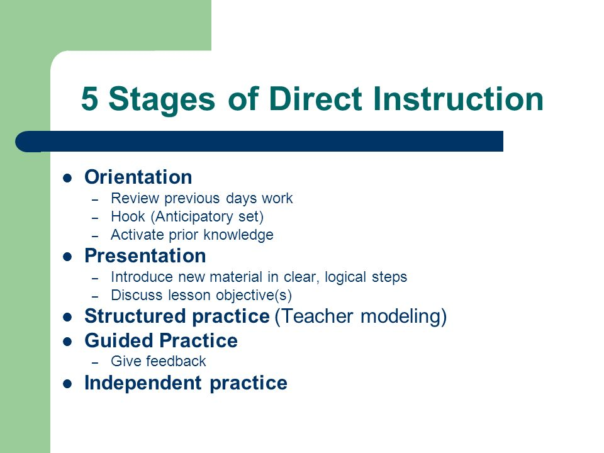

BOOK STUDY – THE LEADERSHIP HANDBOOK
Chapter 6

“The Best Leaders are Listeners”

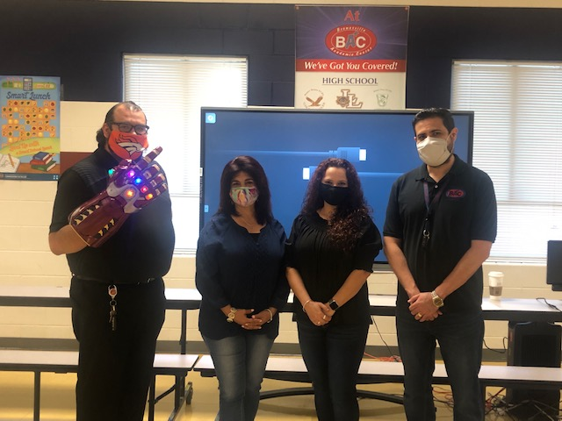

Amazing presentation by the team of Castro, Moreno, Morrison and Zamora.

Elizabeth Duran ……………….. May 6
Fernando Villarreal ………….. May 11
Ignacio Gonzalez …………….. May 29

The BAC library has undergone transformation. The “new look” took place once the maintenance department finished placing the book shelves against the walls. The rest of the work was done by Saul Ibarra, Manuel Garza, Silver Martinez and (missing photo) Elizabeth Villarreal. GREAT JOB ON A LOT OF WORK!
PRINCIPAL NEWS

Thursday, May 13, 2021

A daily round-up of education news and views for the Lone Star State

NATIONAL NEWS

Growing number of schools ditch student mask requirements
Dozens of school districts around the country have eliminated requirements for students to wear masks, and many more are likely to ditch them before the next academic year, despite the Centers for Disease Control and Prevention's guidance that schools “should prioritize universal and correct use of masks and physical distancing.” Data from the CDC shows infection rates among U.S. residents ages 14-17 are now higher than for all Americans, while the rates among children 6-13 are getting closer to the national average. “We know that masks work to reduce transmission,” Gigi Gronvall, a senior scholar at the Johns Hopkins Center for Health Security, said. “This is really not the time to remove one of the best tools we have to reduce transmission.” Meanwhile, as younger children qualify for COVID-19 vaccines, public health officials are unsure of how many families will opt to have their children inoculated if the shots aren’t required for school attendance. While some colleges and universities have made COVID-19 vaccines mandatory for their students, experts say it’s unlikely states will issue similar requirements for K-12 students any time soon. “In the background is the fact that the anti-vaccine movement has been mobilized in past years for every attempt to tighten mandates,” said Dorit Rubinstein Reiss, a professor at the University of California Hastings College of Law and a member of the Vaccine Working Group on Ethics and Policy. “If there is a proposed mandate, we are going to see them mobilize nationally again.” States may eventually add COVID-19 vaccines to their school requirements in future years, but encouragement may be a stronger public health tool this year, she added.
ABC News Education Week Education Week
BOOK STUDY SCHEDULE
5/21/21
Chapter 7
“Get In The Zone And Stay There”
Rodriguez, Dr. Garcia, Trueba
5/14/21
Chapter 6
“The Best Leaders Are Listenorrison, Zamora, Moreno, Castro

6/1/21
Chapter 9
“To See How The Leader Is Doing, Look At The People”
Pinion, Reyes, Hernandez
5/28/21
Chapter 8
“A Leader’s First Responsibility Is To Define Reality”
HRH

6/4/21
Chapter 11
“Keep Your Eye On The Main Thing”
Castillo, West, Ruiz, Villarreal

6/11/21
Chapter 10
“Don’t Send Your Ducks To Eagle School”
Coach Garcia, Tali, Rivera, Olvera

